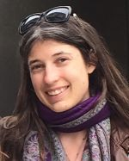
Colleen Alena O’Brien, PhD
Jena Center for Reconciliation Studies
Friedrich Schiller Universität Jena
Fürstengraben 6, 07743 - Jena, Germany
colleenalena@gmail.com
+1 (228) 254-0628

PERSONAL STATEMENT
-
I am a linguist with an interdisciplinary focus in linguistic anthropology and ethnographic filmmaking. My current research focuses on: (1) linguistic typology and analysis, particularly of endangered languages; (2) political discourse analysis in conflict settings; and (3) ethnographic filmmaking as a research method. My PhD dissertation is a grammatical description of Kamsá, a language isolate spoken in southern Colombia, which led to an interest in the Colombian conflict and peace process. As part of an ethnographic documentary, Strangers to Peace, I conducted interviews with former guerrilla fighters of the FARC about their experiences reintegrating into civilian society. The film premiered at the Miami Film Festival and screened at others including the New York Latino Film Festival, Trinidad + Tobago Film Festival, and the Portland Film Festival. I extended this research as a postdoctoral fellow at Friedrich Alexander Universität in Erlangen and Friedrich Schiller Universität Jena. For this project, I built a corpus of transcriptions of the interviews, which I coded using MAXQDA, to examine rhetorical strategies used in political speech. In addition to my fieldwork in Bogotá and Sibundoy (Colombia), I have conducted fieldwork in Jakarta and Gorontalo (Indonesia) and Puerto Cabezas (Nicaragua) studying endangered languages and cultures. So far, my research has been funded by organizations including the National Endowment for the Humanities, Fulbright, and the International Peace Research Association Foundation.

EDUCATION

Ph.D. in Linguistics, University of Hawai‘i at Mānoa. A grammatical description 2018
of Kamsá, a language isolate of Colombia, supervised by Dr. Lyle Campbell.
M.A. in Linguistics, University of Hawai‘i at Mānoa. 2013
B.A. in Anthropology & Classics, University of Miami. Inducted into Phi Beta Kappa, 2010
a national, invitation-only academic society for high-achieving students.

ACADEMIC POSITIONS

Postdoctoral Researcher Dec 2021 – Present
Friedrich Schiller Universität Jena, Center for Reconciliation Studies
- Researched political speech and issues of identity involving ex-combatants of the FARC, resulting in two manuscripts, both under review:
  - “Analyzing political discourse of rebels: collective identity and the us-them dichotomy”
  - “‘We did not feel defeated’: Imaginaries of ex-guerrillas in post-accord Colombia”
- Organized events at the Center with guest speakers on peacebuilding theory and practice.

Lecturer Jan 2022 – Dec 2022
University of Miami, Department of Anthropology
- Taught undergraduate courses in Linguistic Anthropology (APY 204: Introduction to Linguistic Anthropology) and Phonetics (APY 230: Sounds of the World’s Languages).

Postdoctoral Fellow Aug 2020 – Aug 2021
Friedrich-Alexander Universität Erlangen-Nürnberg
Department of Romance Languages and Cultures
- Developed my research agenda with a focus on discourse analysis in conflict settings, resulting in a manuscript and conference presentation:
  - Societas Linguistica Europaea (SLE) conference: “Language contact in Kamsá.” (with Felipe Sandoval Correa), examining the influence of Spanish and Inga (a neighboring indigenous language) on the grammatical structure of Kamsá.
- Taught “Languages and Cultures of the Andes,” a bilingual class (English/Spanish) to undergraduates.

Postdoctoral Fellow (Deutscher Akademischer Austauschdienst.) Dec 2018 – Aug 2019
Freie Universität, Berlin , Institute for Latin American Studies
- Member of an interdisciplinary department that focused on Latin American studies.
- Researched and published an article on the cost-effectiveness of the Colombian reintegration agency’s program for ex-combatants that appeared in Research in Economic Anthropology.
- Participated in workshops and conferences, including giving talks about the effects of the armed conflict on Indigenous languages in Colombia, ethnographic filmmaking, the transformation of demobilization camps in Colombia, and Kamsa morphosyntax.

PEER-REVIEWED PUBLICATIONS
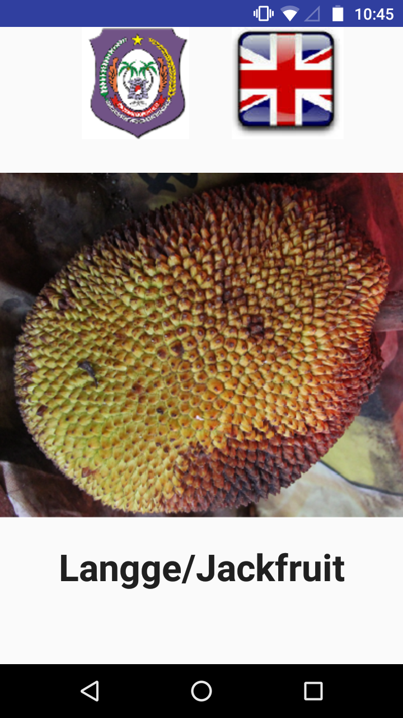
O’Brien, C. A. & Sherris, A. 2022. “Exploring the uses of multilingual dictionaries among the Safale̱ba in Ghana and the Gorontalo in Indonesia.” In R. Valijarvi and L. Kahn (Eds.), Teaching and Learning Resources for Endangered Languages. Leiden: Brill. Forthcoming.
- This article examines how teachers in one ethnolinguistic community (Safaliba, in Ghana) and parents in another (Gorontalo, in Indonesia) use pedagogical learner dictionaries. Findings indicate that local activists in Gorontalo have produced a trilingual dictionary and corresponding app in Indonesian, Gorontalo, and English. Similarly, Safaliba teacher-activists have produced their own bilingual dictionary.
- We evaluated the potential for a smartphone app to revitalize the Gorontalo language among younger members of the community (see screenshot of the Gorontalo and English translations for “jackfruit” in the learner app).
- My contribution focused on analysis of Gorontalo language.

O’Brien C.A. 2022. “Ethnographic filmmaking for understanding peacebuilding: A multi-sited and multi-modal approach.” In Melissa Nolas, Christos Varvantakis, and Rachael Stryker (Eds.) Experiments in Worldly Ethnography. Routledge. Forthcoming.
- This chapter discusses new methodological approaches toward generating and presenting ethnographic knowledge in order to inform peacebuilding activities. I explore how a multi-sited approach provides insights into the population of ex-combatants in Bogotá, the nation’s megacity of over 10 million inhabitants, as well as the rural camps where ex-combatants live.
- Using these two sites, one urban and one rural, offers diachronic insights since the people in Bogotá are years into their reintegration process, whereas those in the camps have yet to start. The discussion also illustrates the connectedness between the urban and the rural.
- Throughout, I employ a multi-sited and multimodal methodology to develop my argument.

O’Brien C.A. 2021. “Assessing Cost-effectiveness in Reintegrating Ex-combatants in Colombia.” In Wood, D.C. (Ed.) Infrastructure, Morality, Food and Clothing, and New Developments in Latin America (Research in Economic Anthropology, Vol. 41), Emerald Publishing Limited, Bingley, pp. 217-252. https://doi.org/10.1108/S0190-128120210000041010
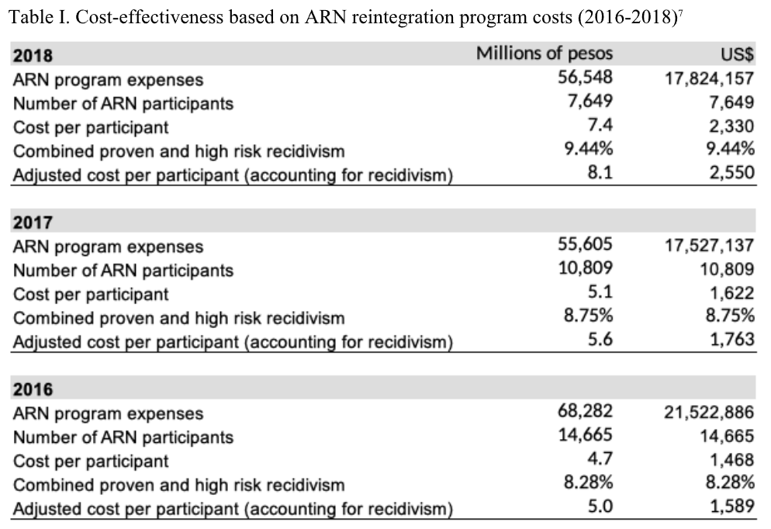
- This article evaluates the cost-effectiveness of the Colombian government’s reintegration program, focusing on the agency's approaches (past, current, and proposed) toward reintegrating ex-combatants from armed groups while comparing financial costs against outcomes.
- I evaluate the cost-effectiveness of both the overall program and its outcome across different regions and demographics of the participant population and suggest ways that other countries facing the challenge of reintegrating ex-combatants can learn from Colombia.

O’Brien C.A. 2021. “A typological sketch of Kamsá, a language isolate of Colombia.” Forma y Función. Vol 34; No 2. https://doi.org/10.15446/fyf.v34n2.88673
- This article examines Kamsá, a language isolate spoken in the Sibundoy Valley in Putumayo, Colombia. I describe various grammatical features of Kamsá, including its phonology, nominal morphology (especially noun class and case marking), verbal morphology (especially person/number marking for core arguments and evidentiality), morphosyntactic alignment, and syntax (including discussion of causatives, comparatives, and subordinate clauses). In doing so, I places Kamsá within its typological and geographical context, between the Amazon and the Andes.

O’Brien C.A. 2022. “Conversations about violence during fieldwork in Colombia.” In Linda Green and Nerina Weiss (Eds.), Loose ends of fieldwork. Routledge.

Rojas-Páez, Gustavo and O’Brien C.A. 2020. “Narratives on Indigenous victimhood: Challenges of Indigenous data sovereignty in Colombia’s transitional setting.” Chapter in Indigenous Data Sovereignty and Policy. Edited by Maggie Walter, et al. London: Routledge.
O’Brien, C.A. and Everett, Caleb. 2020. “Color salience, color term evolution, and the issue of relatedness.” In The Evolution of Language: Proceedings of the 13th International Conference (Evolang13). Edited by Andrea Ravignani, et al. Nijmegen: The Evolution of Language Conferences.

O’Brien, C.A. 2019. “Challenges of Kamsá language revitalization in Colombia.” Chapter in Rejecting marginalized status: Educational projects and curricula pushing back against language endangerment. Edited by Ari Sherris and Susan Penfield. Bristol: Multilingual Matters.
https://doi.org/10.21832/9781788926263-005
- This chapter explores the efforts of the Kamsá in southern Colombia to preserve their language. The Kamsá language is severely endangered, with fewer than 1000 speakers and interrupted inter-generational transmission. The Kamsá are aware that the language is being lost and are making efforts to revitalize it. I review the material resources at their disposal, including a number of bilingual schools in Sibundoy, a Kamsá preschool in Bogotá, an app for phones, a radio station, and several websites and books. There are some plans for improving language revitalization, including using more technology and involving children in traditional activities, but the Kamsá continue to face significant challenges.

O’Brien, C.A. 2016. “The case of og: Focusing arguments in Western Subanon.” 20th Annual LLL Graduate Student Conference Proceedings University of Hawai‘i at Mānoa.

O’Brien, C.A. 2016. “Are Philippine languages ergative? Evidence from Western Subanon.” Working Papers in Linguistics. University of Hawai‘i at Mānoa.

CONFERENCE PRESENTATIONS

“Language contact in Kamsá.” With Felipe Sandoval Correa (2022). Societas Linguistica Europaea (SLE) conference, Bucharest, Romania.

“Exploring the asymmetries of symmetrical voice: The case of Gorontalo.” With Novi Usu (2022). Meeting of Southeast Asian Linguistics Society. Honolulu, Hawai‘i.

“Gorontalo and Safaliba languages and literacies: Indigenous meaning making and practice.” With Ari Sherris (2022). American Association for Applied Linguistics Annual Conference, Pittsburgh, Pennsylvania.

“Conflict temporalities and Indigenous victimhood narratives within Colombia’s transition justice scenario.” With Gustavo Rojas-Páez (2020). Zentrumstage 2020: (Re)thinking Time and Temporalities in Peace and Conflict. University of Marburg. 29–31 October 2020.

“Exploring the uses of multilingual dictionaries among the Safaliba in Ghana and the Gorontalo in Indonesia.” With Ari Sherris (2020). Paper presented at Annual Conference of Foundation for Endangered Languages. 23–25 September 2020.

“Voice systems of Western Austronesian languages: Emerging evidence from Indonesia” (2020). Paper presented at Conference for Indonesian Languages and Linguistics. Atma Jaya University, Jakarta, Indonesia. 16–18 February 2020.

“Language endangerment and revitalization in Colombia: New political challenges” (2019). Paper presented at The Ninth Cambridge Conference on Language Endangerment. University of Cambridge. 02 July 2019.

“Transformation of the ETCRs: (Espacios Territoriales de Capacitación y Reincorporación) in Colombia and the implications for peace” (2019). Paper presented at Colombian Days. Jena, Germany. 27–28 May 2019.

“Between noun class and classifier: The case of Kamsá” (2019). Paper presented at Noun Categorization: From Grammar to Communicative Interaction. Lyon, France. 18–19 April 2019.

“In search of practical peacebuilding strategies for a changing Colombia” (2019). Paper presented at the Society for Applied Anthropology meeting. Portland, OR, USA. 19–23 March 2019.

“Retos de reintegración de las FARC: una perspectiva del cine etnográfico” (2018). Paper presented at Entendiendo a los grupos excombatientes: Metodologías alternativas para la investigación del conflicto armado colombiano. Workshop held at: Lateinamerikanisches Institut FU Berlin. December 19, 2018.

“The mysterious case of =em: Grammaticalization of a serial verb construction in Fataluku.” With Yuko Otsuka (2017). Paper presented at APLL 9 (Austronesian and Papuan Languages and Linguistics Conference). Paris, France. 21–23 June 2017.

“Creating relevant curricula for endangered languages in Colombia” (2016). Paper presented at the Sixth Cambridge Conference on Language Endangerment. University of Cambridge. July 6, 2016.

“At the crossroads of language death: Displacement, language loss, and identity in Colombia” (2016). Paper presented at the annual meeting of the Society for Applied Anthropology, Vancouver, Canada. March 2016.

INVITED PRESENTATIONS

International Peace Research Association annual conference. Plenary speaker. Trinidad and Tobago May 17-21, 2023.

Fulbright Panel Discussion. Invited speaker for “Indigenous Languages: Endangerment and Documentation” hosted by AMINEF and the Centre for Endangered Languages Documentation (CELD), Faculty of Literature and Culture, Universitas Papua in Manokwari, West Papua. February 21, 2020.
- Participated in a panel discussion with local university students in Manokwari in Indonesia on language endangerment issues, comparing language loss dynamics in Colombia and Indonesia. Additionally, conducted a radio interview facilitated by the Fulbright Program to engage with local communities.

SCHOLARSHIPS, GRANTS, AND FELLOWSHIPS

CAORC National Endowment for the Humanities – Sr. Research Fellowship Aug 2021 – Jul 2022
- Project: “Collaborative Documentation, Description, and Analysis of the Gorontalo Language.”
- Described the grammatical system of the Gorontalo language of northern Sulawesi. Provided insights into the dynamics of language shift affecting Gorontalo and other language families. Collaborated with native speaker academics and community members. Applied mixed methods from linguistics and linguistic anthropology, including audio-visual documentation, participant observation, and interviews and surveys.
- Developed methods of working together remotely with collaborators during the pandemic These collaborations resulted in a co-authored conference presentation with Novi Usu, which we are currently developing into a monograph. I will return to Indonesia in late 2022 to extend the project.

Fulbright Fellowship Nov 2019 – Apr 2020
Fulbright Program Indonesia
- Project: “Documentation and Description of Gorontalo, a language of Sulawesi.”
- Carried out fieldwork in Indonesia to document and study the characteristics of the endangered language spoken by the Gorontalo people. The Fulbright program is designed to encourage international collaboration, thus I made it a priority to establish connections and mutual knowledge exchange with the local community, including Japesda, a local NGO, and students/faculty from Gorontalo State University.

Firebird Foundation grant Nov 2019 – Jul 2020
- Project: “Documentation of traditional ecological knowledge and oral history of the Gorontalo.”
- Began documenting the ecological and cultural practices and oral literature of the Gorontalo people in Indonesia. The project was terminated due to the pandemic.

International Peace Research Association Foundation grant. Dec 2017 – June 2018 Project: “Investigating the Reintegration of FARC Combatants through Ethnographic Filmmaking.”
- IPRAF funded my initial research into peacebuilding and ethnographic filmmaking, including a trip to Colombia, which has resulted in a long-term relationship. IPRAF currently promotes my film on their website, and I will participate in future events sponsored by the foundation.

Bilinski Dissertation Fellowship Aug 2018 – Dec 2018
Fellowship awarded to University of Hawai’i PhD students to complete their dissertation.

American Association of University Women Fellowship Aug 2017 – Jul 2018
Funded my doctoral fieldwork and recognized my commitment to working with Indigenous women.

Lewis and Clark Exploration Grant, American Philosophical Society Oct 2016 – Dec 2016
Documentation and description of Kamsá. This grant funded my initial fieldwork trip in Colombia where I built contacts with the Kamsá community and set the groundwork for my PhD research.

Foreign Language Area Studies (FLAS) Jun 2013 – Jul 2013
Studying the Miskitu language in Nicaragua via a U.S. government grant to study a foreign language.

Gilman International Scholarship, Jan 2009 – May 2009
Study abroad in Prague. This scholarship is offered by the U.S. governments to students from low socioeconomic class with high grade point averages to allow them to study abroad.

FILM PROJECT
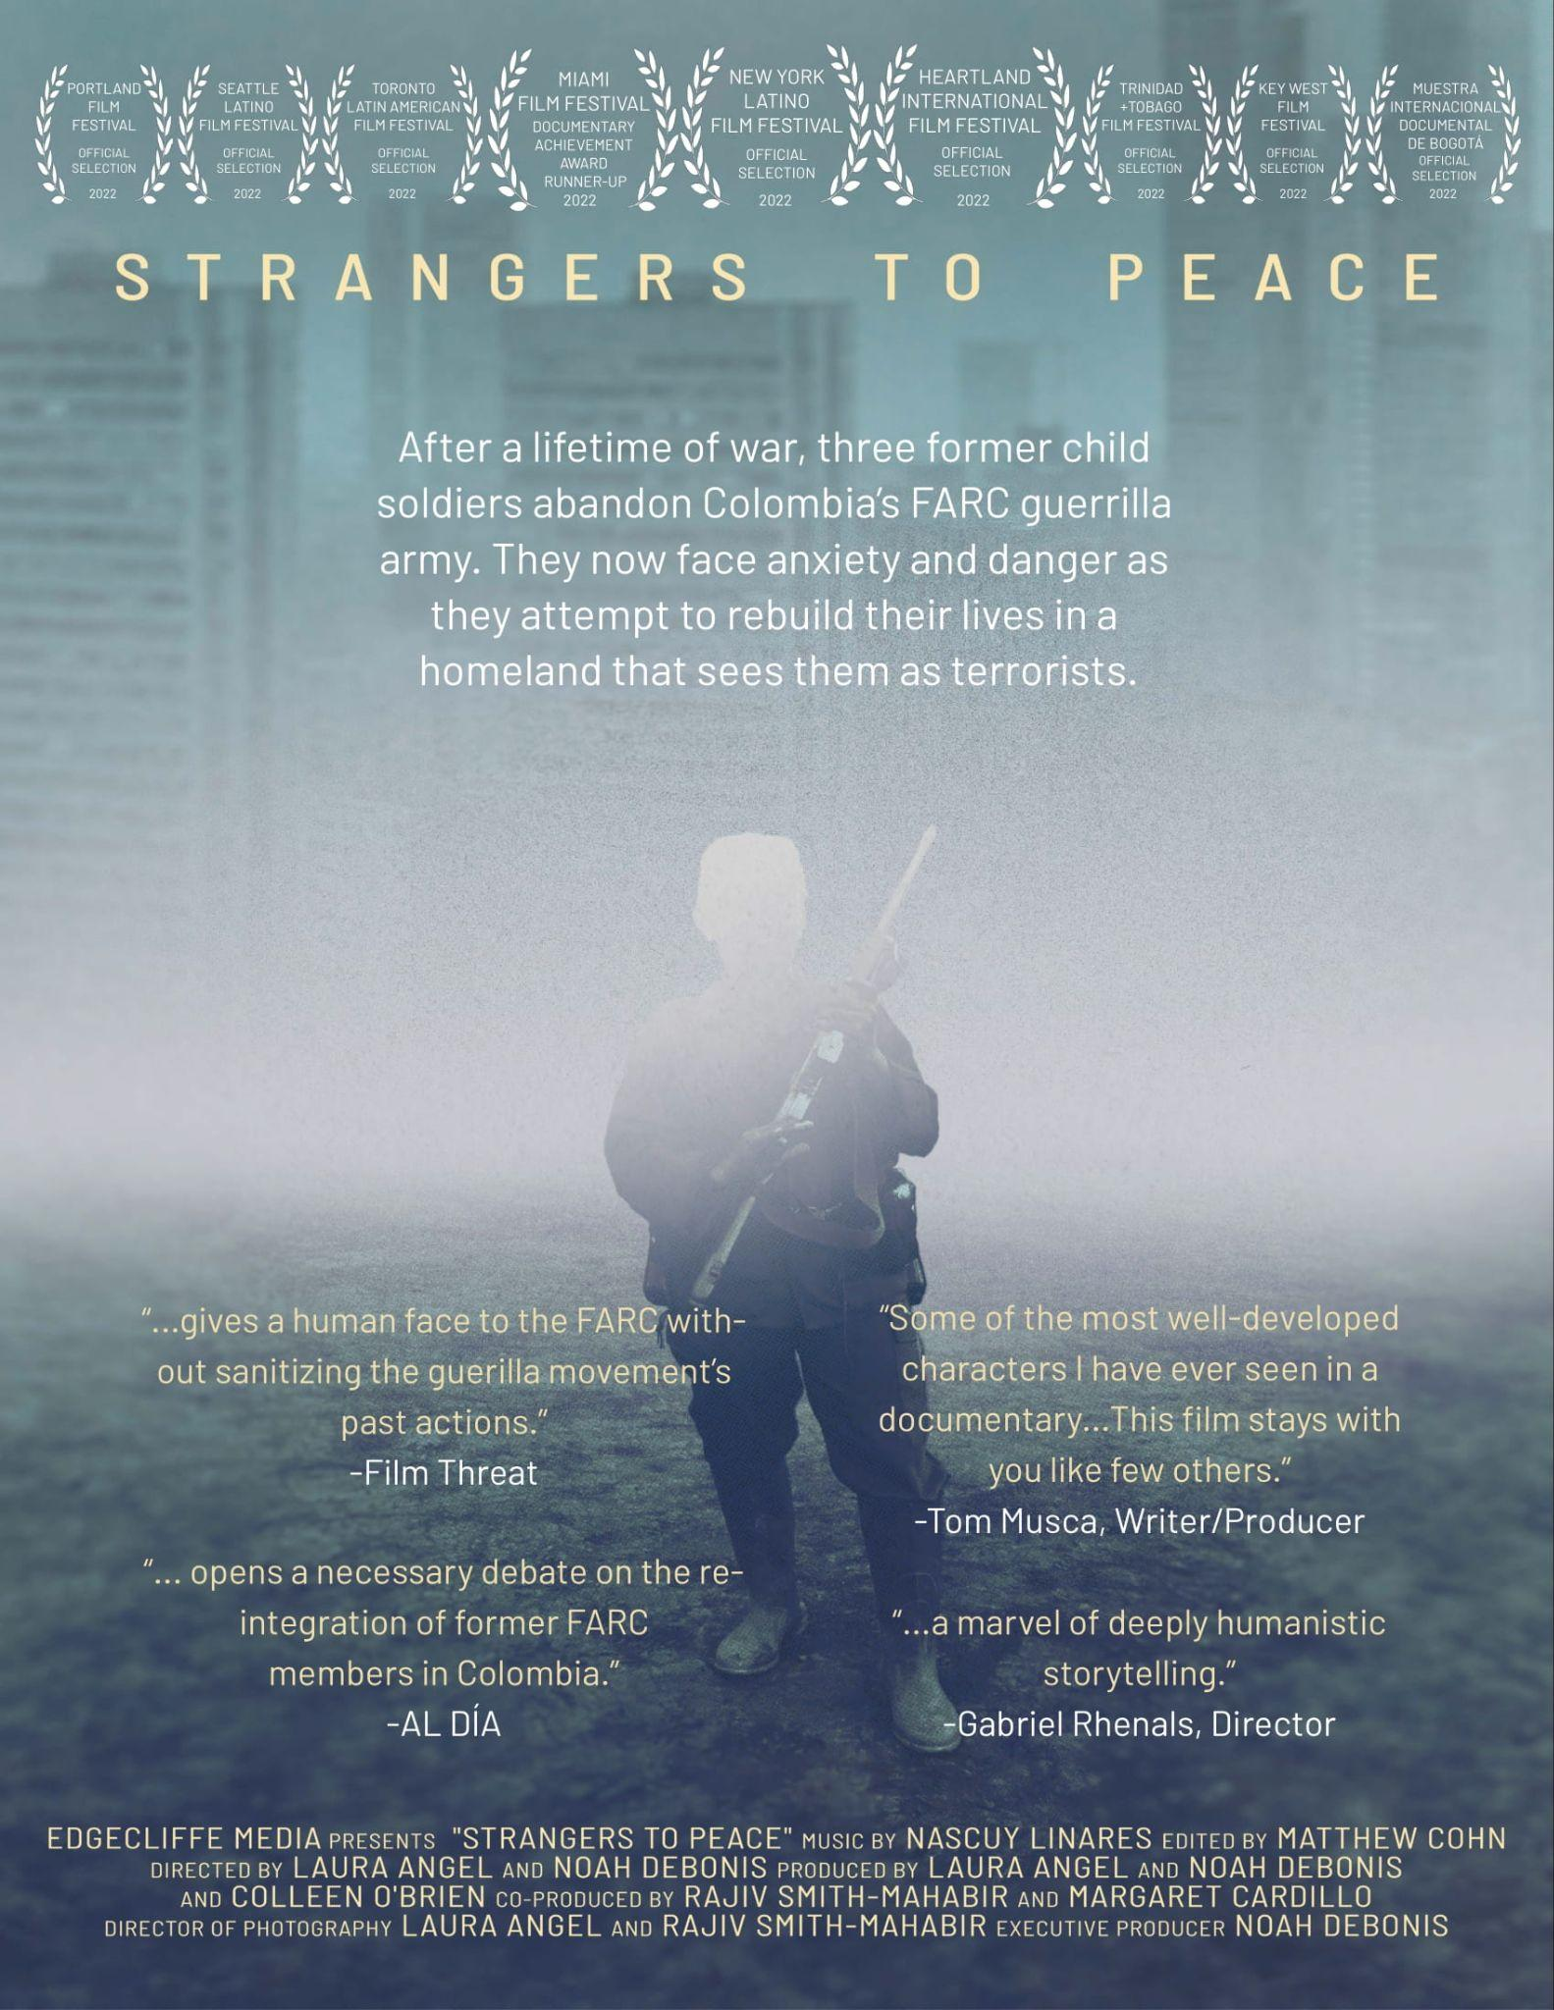
-
Film Producer, Strangers to Peace Sept 2016 – Present
- Conceived the initial idea and ethnographic methods for this feature-length documentary (88-minutes).
- Logline: “In Colombia, after 52 years of civil war, three guerrilla soldiers attempt to return to a society that views them as terrorists.”
- Premiered at Miami Film Festival in March 2022, where it won Documentary Achievement Award Runner-up.
- Won the Vaclav Havel award at the One World Festival in Prague.
- Screens later in 2022 at the New York Latino Film Festival, Portland Film Festival, Heartland International Film Festival, Toronto Latin American Film Festival, and many more.
- Secured funding and support (with DeBonis and Angel) from Sundance Institute, International Peace Research Association Foundation, University of Miami, and Bogotá Audiovisual Market.
- Organized shoots, managed relationships with our participants, and collaborated with government officials, agencies, FARC members and commanders, victims, and local authorities.
- Planned additional screenings at universities.
- Website: www.strangerstopeace.com

ACADEMIC SERVICE

Editor 2023
Journal of Reconciliation Studies

Reviewer
International Journal of Transitional Justice 2022

Reviewer
Diálogos de Saberes 2021

Organizing Committee Member 2023
International Association of Reconciliation Studies annual conference

Organizing Committee Member Aug – Dec 2013
International Conference for Language Documentation and Conservation (Honolulu, Hawai’i)

